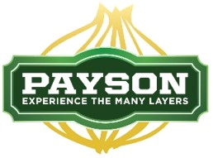

Payson City WWTP
Pretreatment Program

The Payson City pretreatment program is to protect the sewer collection system, wastewater treatment plant, and environment and employees safety by controlling the discharge of toxic, harmful or untreatable waste to the sewer collection system.

The program applies to facilities including restaurant and food establishments, auto body shops, medical facilities, photo shops, dry cleaners, etc.

The Pretreatment Coordinator must review business license applications before the license can be issued.
To facilitate the review, please complete the following:

- Fill out the wastewater treatment forms. The form must be completely filled out and signed.
  - Included chemicals on-site and their location.
  - List or map floor drain locations.
  - Include a blueprint or site map if available.
- An inspection is required by the Pretreatment Coordinator. Call 801-465-5277 (office) or 801-404-6476 (cell) to schedule an inspection.
  - All restaurants and food establishments must install and maintain a grease trap or grease interceptor.
    - Documentation of the last cleaning of the grease trap/interceptor or sand trap is required.
    - The device must be open during inspection.
  - Auto body shops floor drains must be closed off, they cannot connect to the Sewer Collection System.
- Business operations shall not start until the business license is issued.
- Additional information may be required during the review process.

Please call the Pretreatment Coordinator if you have any questions or concerns at 801-465-5277 (office) 801-404-6476 (cell).

